Biology, Castle View High School  
Jason R Mayberry, PhD

Study Guide: Ionic and Covalent Bonds

**Vocabulary**

1. Ionic Bond
2. Compound
3. Covalent Bond
4. Single Bond
5. Double Bond
6. Triple Bond
7. Chemical Formula

**Conceptual Questions**

1. Describe how an ionic bond is formed, and how it satisfies the two requirements for the atom to be stable.

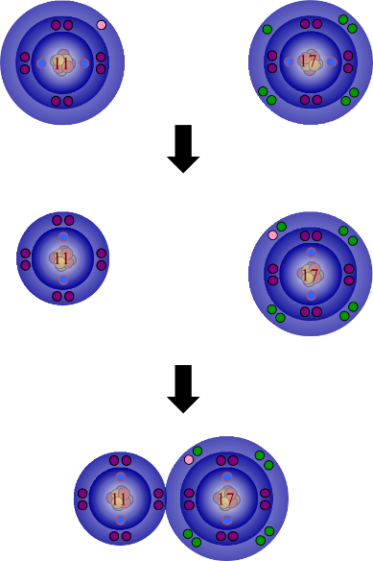

1. Describe and give an example of how to draw the Lewis dot structure for ionic bonds.
2. Explain how different combinations of atoms that can come together to form ionic bonds.

*Begin with NaCl: what could replace Na? what could replace Cl?*

1. Be able to use the periodic table to make up and draw a variety of ionic bonds with a variety of ions.
   1. *Draw a compound with any set of atoms from group 1 and group 17*
   2. *Draw a compound with any set of atoms from group 2 and group 16*
   3. *Draw a compound with any set of atoms from group 1 and group 16*
   4. *Draw a compound with any set of atoms from group 2 and group 17*
2. Explain why ionic bonds don’t usually result in discrete molecules (instead they form compounds with crystal latices)

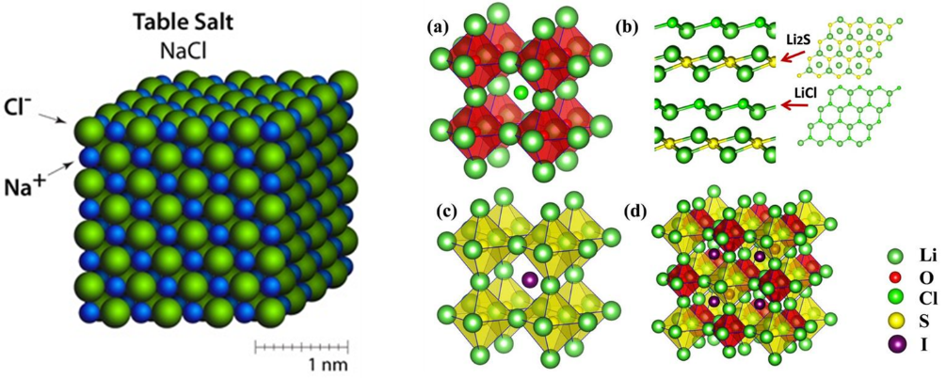

1. Describe how covalent bonds form, and explain how it satisfies the two requirements for the atoms to be stable.

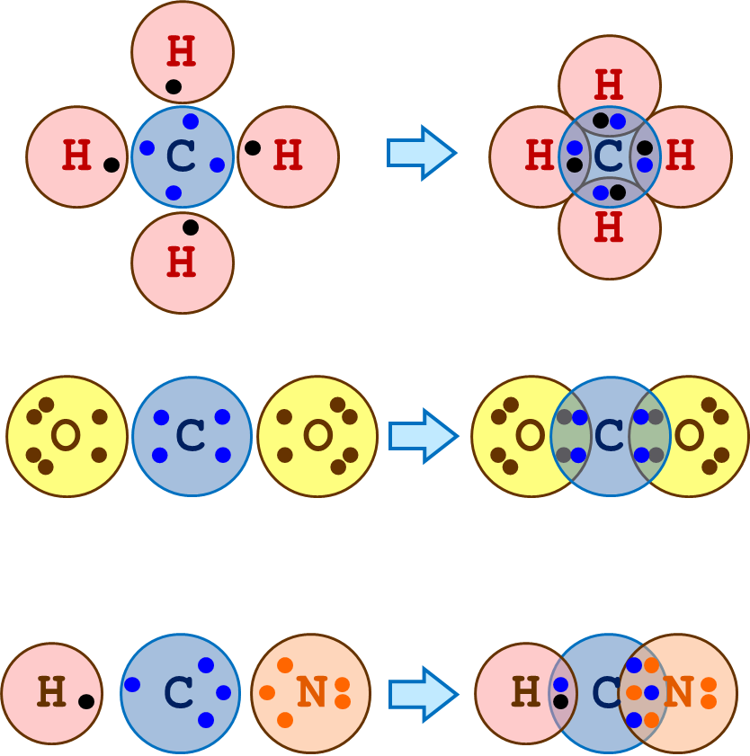

1. Explain how to determine how many covalent bonds an atom will form.

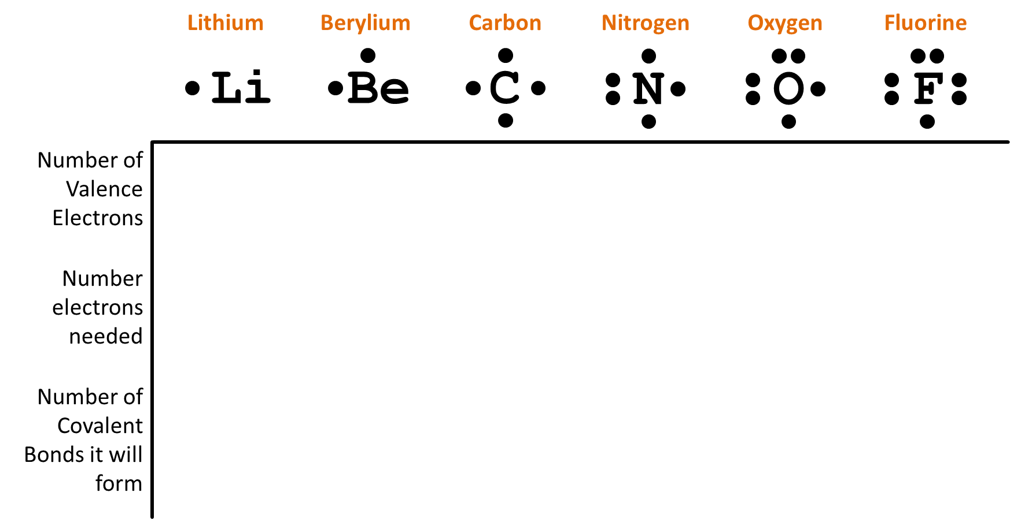

1. Explain why some atoms (e.g. groups 1 and 2) won’t form covalent bonds.
2. Be able to draw the Lewis dot structure for covalent bonds, including single, double, and triple bonds.
   1. *Example: CH4*
   2. *Example: CO2*
   3. *Example NH3*
3. Given a chemical formula, be able to determine if the bonds between individual atoms will be ionic or covalent.
   1. NaCl
   2. HCN
   3. MGI2
   4. CO2
   5. C6H12O6
4. Be able to draw a variety of large molecules with covalent bonds between a variety of different atoms.
   1. Example: Draw at least two examples of molecules with the formula: C4N2O2H? (*where H? means you can vary the number of Hydrogens as needed)*
5. Given a drawing of a molecule (ionic or covalent), be able to determine if the drawing is correct, and if it isn’t correct, what is wrong with it.